**STEPS TO IMPLEMENT THE CODE:**

* First of all, write the appropriate code in the Pycharm IDE, and change the folder name and path in the code.

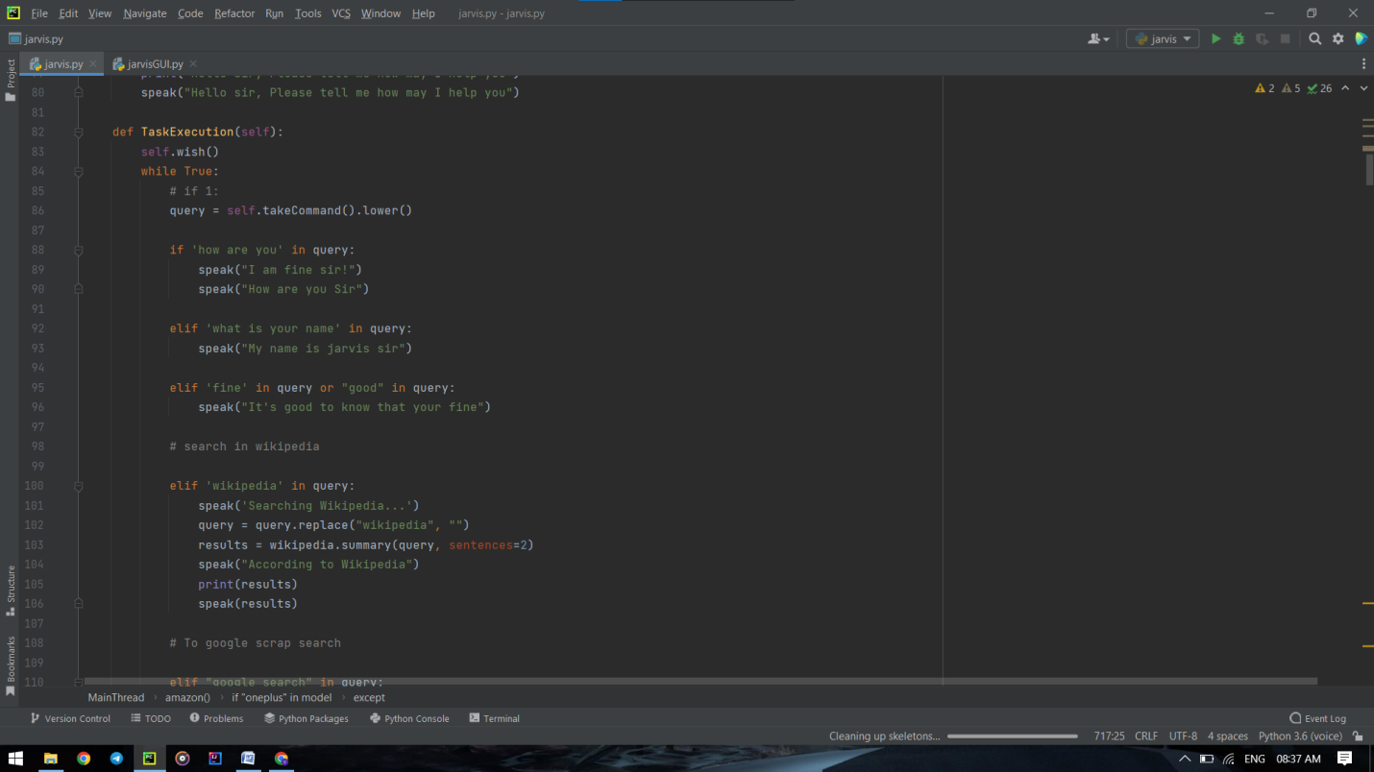

* Then, import the mentioned packages in the libraries file.

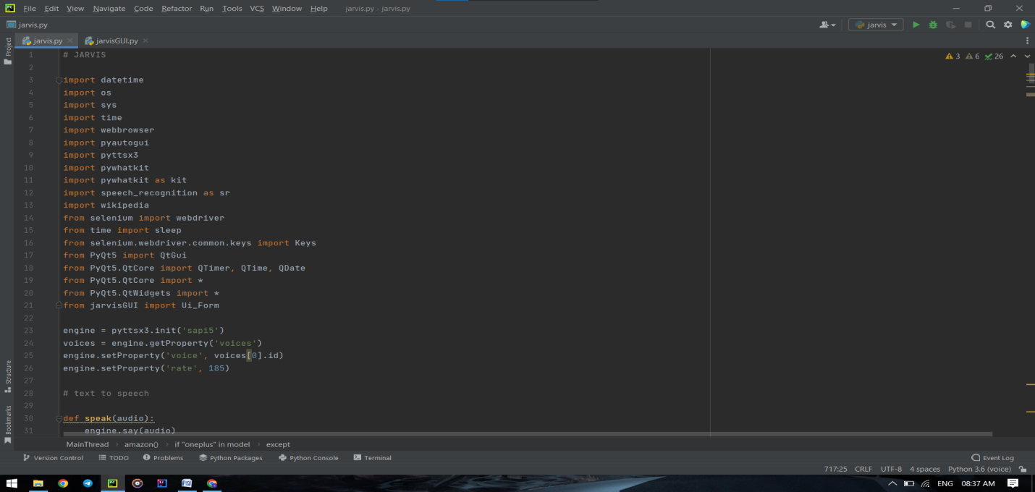

* After the libraries are imported, open a new python file and name it as Jarvis.GUI.

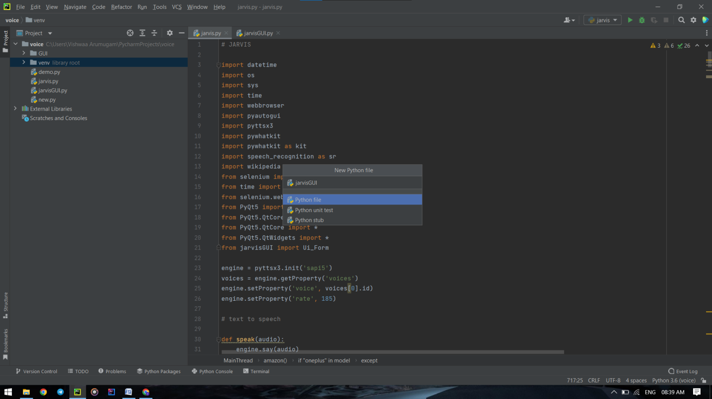

* Change the path of the images used in the GUI.

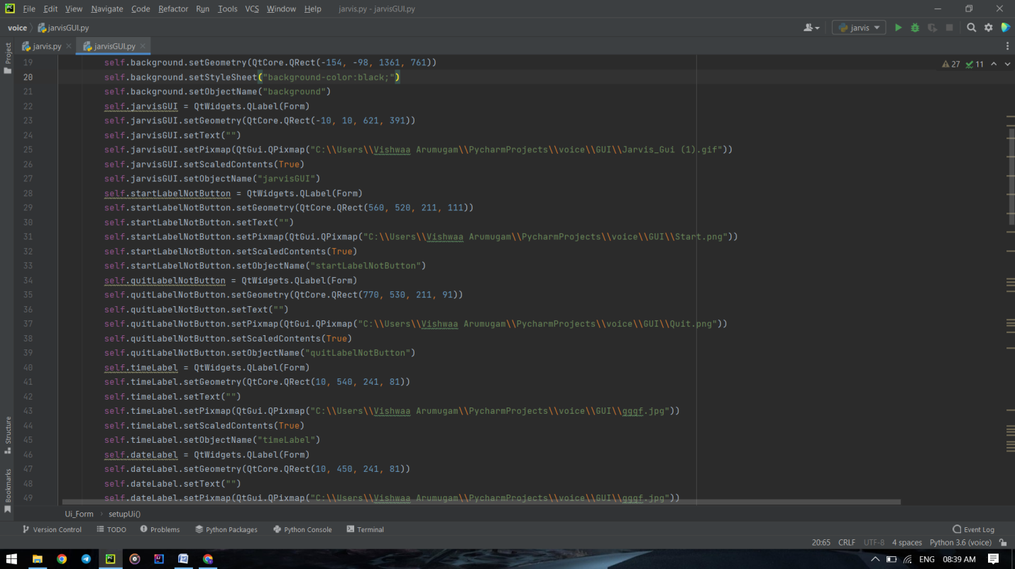

* Run the code.

